BIT 4107 – Mobile Application Development
ENHANCED PROFESSIONAL STUDENT LOGBOOK
Student Name : Kalunde Caroline
Admission Number: BIT/2024/52267
School/Faculty: Computing And Informatics
Programme: Bachelor of Information Technology
Academic Year: Year 3
Semester: 2ND
Lecture: Michael Nyoro
Phone Number: 0714474754

Week 1: Introduction To Mobile Application Development
Practical Activities Undertaken:
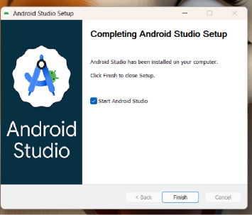
Figure 1.1: Android Studio Setup
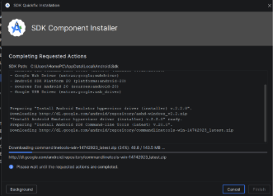
Figure1.2: SDK platforms build
Downloaded the Flutter SDK and initialized the Android Studio installation package. Worked through the initial IDE setup wizards, configured basic SDK command-line dependencies, and mapped out the initial project folders for the upcoming application.
Tools/Software Used:
Android studio installer, flutter SDK, windows file explorer.
Personal Reflection:
Gained a clear understanding of mobile application lifecycle concepts. Laying down a structured roadmap early helped clarify how the individual modules of the application will eventually connect, highlighting the importance of proper planning before writing any code.

Week 2: Mobile Development Environment
Practical Activities Undertaken:
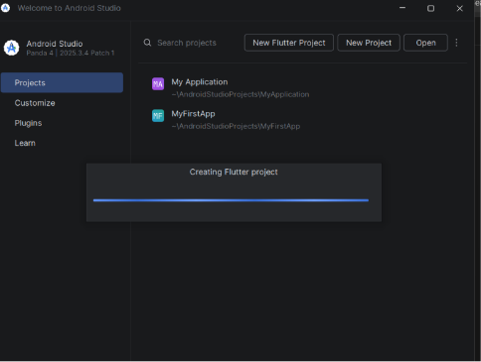
Figure 1.3: Generating flutter framework
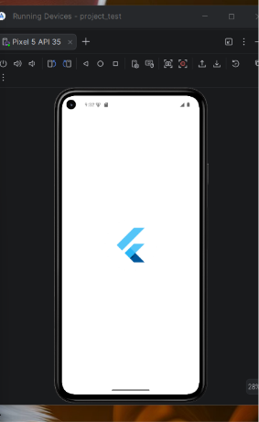
Figure 1.4: Generated flutter project inside Android studio
Configured environmental system variables to link the Flutter SDK globally. Initialized and generated the project repository template (named AfyaFlow) inside Android Studio. Reviewed the automatically generated project architecture files, modified the baseline main.dart script to establish a clean environment, and successfully executed a test run on the target virtual device emulator to verify that the template application compiled without errors.
Tools/Software Used:
Android Studio IDE, Flutter SDK, Dart SDK, Command Prompt terminal, Android Virtual Device (AVD) emulator.
Personal Reflection:
Creating my very first Flutter application structure was an exciting and vital milestone. Learning how the framework automatically bootstraps complex multi-platform folders (like android and ios directories) alongside our working lib folder made me appreciate how build tools handle cross-platform compiling behind the scenes. Successfully running the baseline build confirmed that my entire workspace environment is fully operational and ready for custom interface coding.
Week 3: User Interface Design
Practical Activities Undertaken:
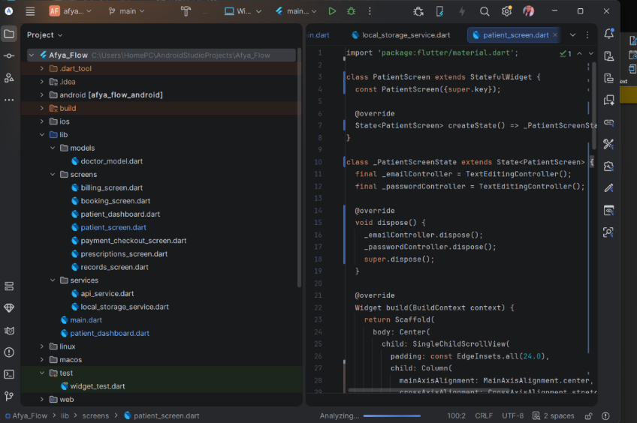
Figure 1.5: Patient screen and GUI
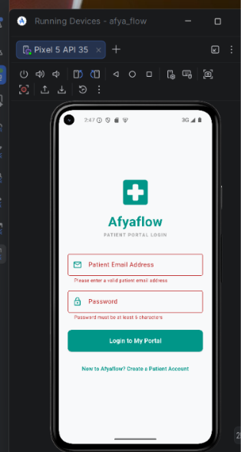
Figure 1.6: Finalized user interface
Designed and developed the user interface for the core application authentication layout, focusing specifically on the Patient Login Screen. Built out the form containers using text fields for input values, designed submission button states, and managed custom interface spacing properties within a newly structured screens folder directory to handle presentation views separately from core logic files.
Tools/Software Used:
Android Studio, Flutter Framework, Dart Layout Widgets (Column, TextField, ElevatedButton).

Personal Reflection:
Working on the patient login screen helped me understand how to combine individual Flutter input widgets into a cohesive, user-friendly login layout. Designing user fields from scratch showed me how critical clear form structures are for building interfaces that feel intuitive and responsive for patients.

Week 4: Event Handling and User Interaction
Practical Activities Undertaken:
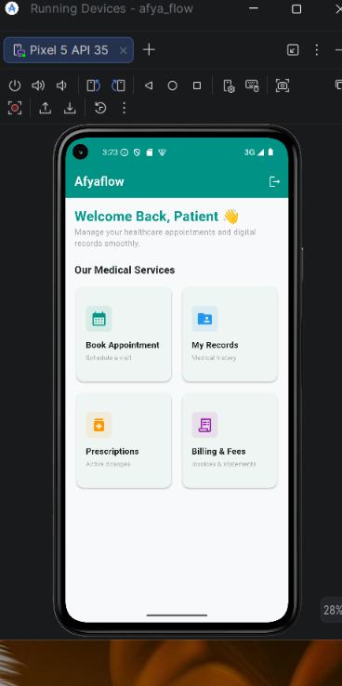
Figure 1.7 : implementing navigation routes
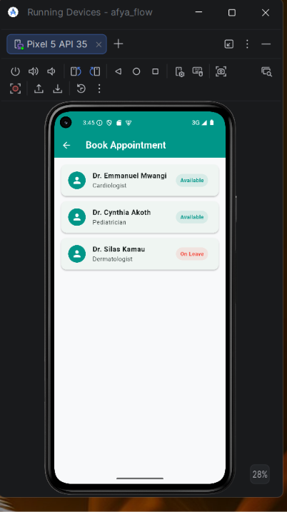
Figure 1.8: Testing interactive text input states on patient login interface
Implemented event handling and interactivity layers across the application forms. Linked TextEditingController instances to the Patient Login input fields to securely capture user credentials. Programmed interactive button state behaviors using onPressed callbacks and integrated Flutter's Navigator class to route users seamlessly from a successful login action directly into the Patient Dashboard view.
Tools/Software Used:
Android Studio, Flutter Framework, Dart Async Programming (Navigator.push, TextEditingController).
Personal Reflection:
Moving from static UI designs to interactive event handling made the application feel alive. Managing input data collection and screen routing logic gave me great insight into how user events drive a mobile application state, emphasizing how vital immediate interface feedback is for user satisfaction

